Electric Drives
and Controls
Linear Motion and
Assembly Technologies
Hydraulics
Pneumatics
Service
MTX micro
数控系统电气连接
孙雷
1


议题安排
 系统结构介绍
 VDP80系列机床操作面板
 HCT/HCQ 系统及驱动控制系统
 电机及其附件
2/28/2009, BRCN/SLC31
2
© Bosch Rexroth AG 2009. All rights reserved, also regarding any disposal, exploitation, reproduction, editing, distribution, as well as in the event of applications for industrial property
rights.
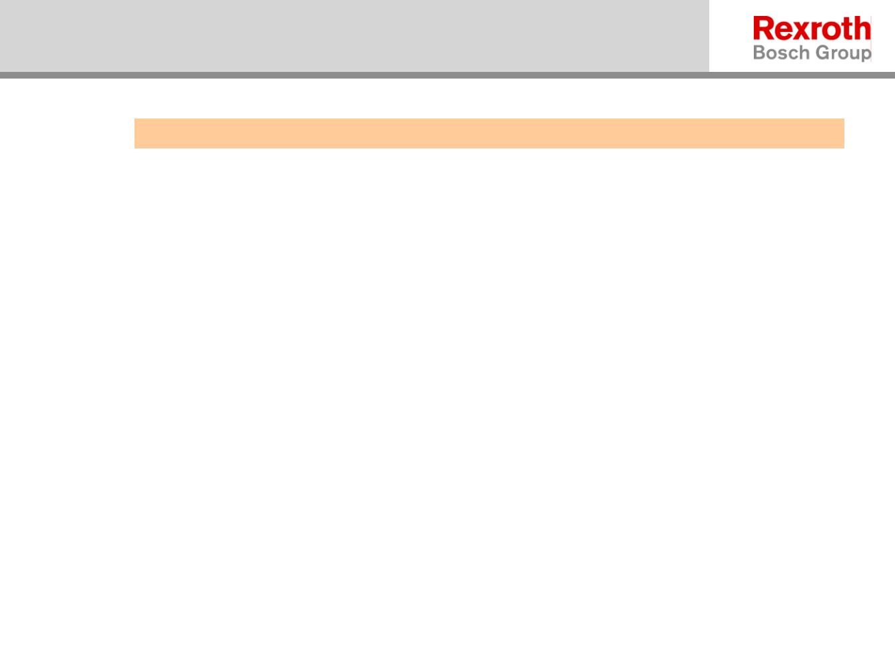

IndraMotion MTXmicro-c
4轴版 HCQ02
TCP/IP以太网
HMI通讯线
+24V DC
VDP80
手持盒
轴 3 – 12Nm 伺服电机
轴 4 – 12Nm伺服电机
主轴第二编码器
HCQ02
轴 2 – 17Nm伺服电机
5kW主轴电机
轴 1 – 11kW主轴电机
11kW变频器
2/28/2009, BRCN/SLC31
3
© Bosch Rexroth AG 2009. All rights reserved, also regarding any disposal, exploitation, reproduction, editing, distribution, as well as in the event of applications for industrial property
rights.
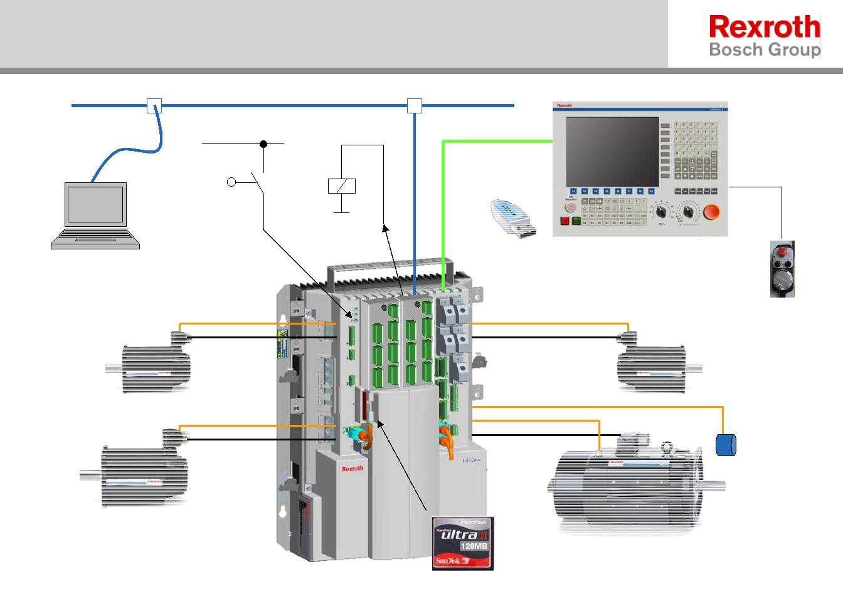

议题安排
 系统结构概述
 VDP80系列机床操作面板
 HCT/HCQ 系统及驱动控制系统
 电机及其附件
2/28/2009, BRCN/SLC31
4
© Bosch Rexroth AG 2009. All rights reserved, also regarding any disposal, exploitation, reproduction, editing, distribution, as well as in the event of applications for industrial property
rights.
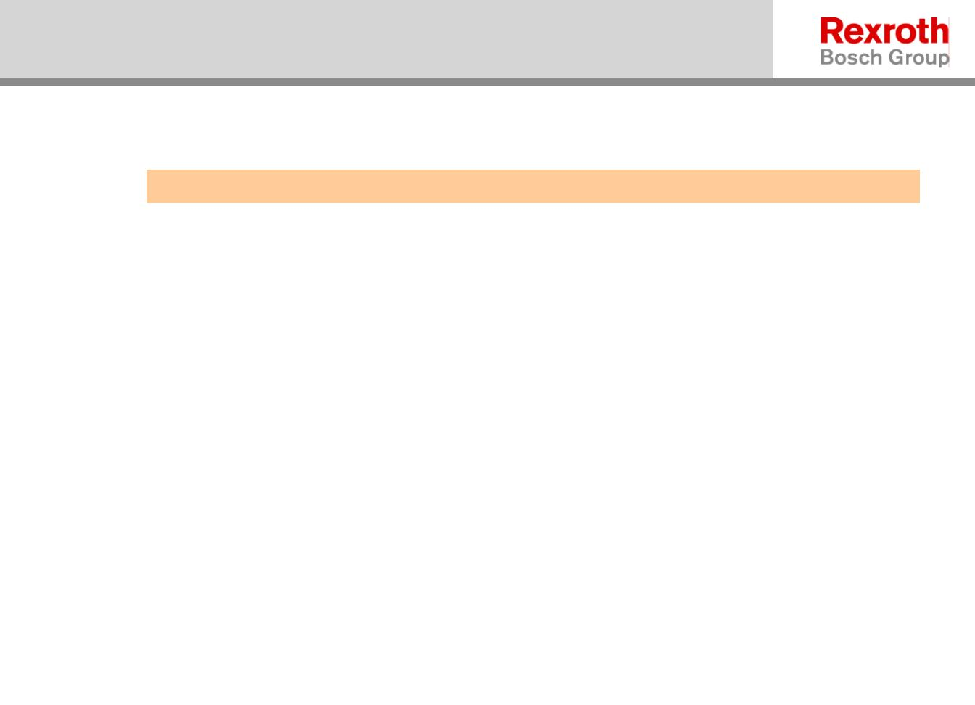

IndraMotion MTXmicro-c
VDP80 HMI 车床版
VDP80.1FAN-..-EN
VDP80.1FAN-..-CH *)
*)中文
2/28/2009, BRCN/SLC31
5
© Bosch Rexroth AG 2009. All rights reserved, also regarding any disposal, exploitation, reproduction, editing, distribution, as well as in the event of applications for industrial property
rights.
