MTX micro操作简介
胡虎
（BRCN/SLC31）
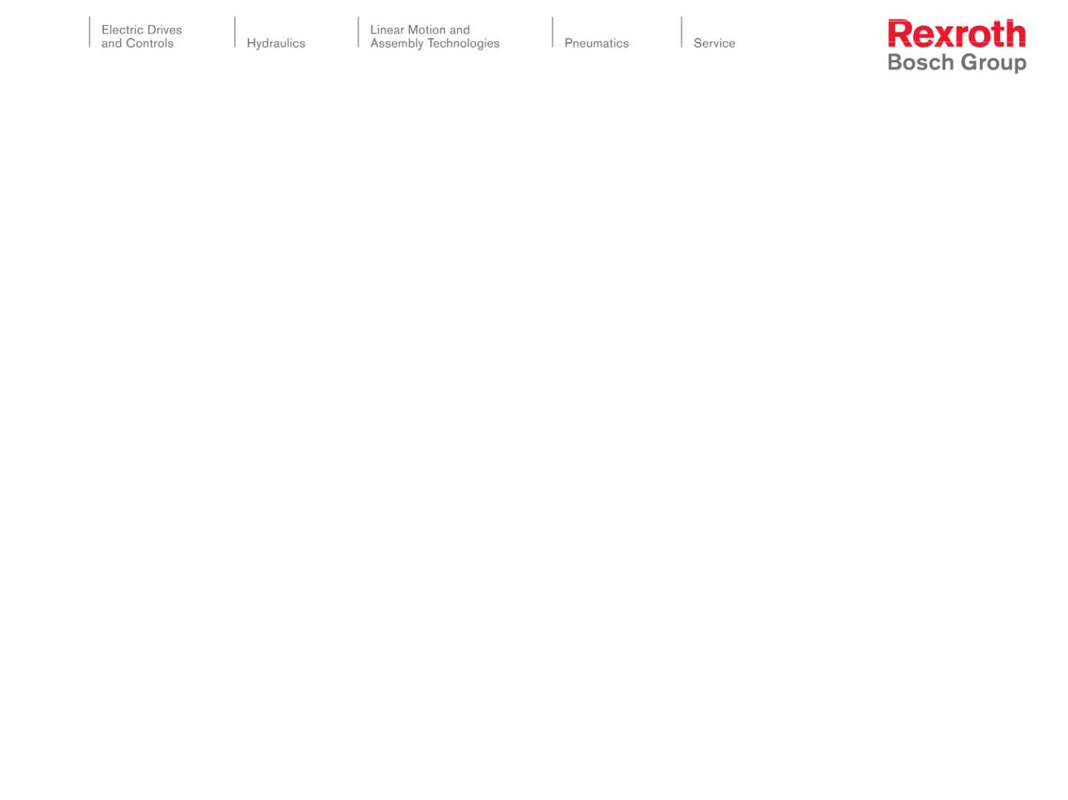

车床/铣床面版对比
车床版
铣床版
8.4”显示器
轴选开关/手轮
32个机床操作按钮
10.4”显示器
主轴倍率开关
36个机床操作按钮
Electric Drives and Controls 11/Mar/2009; BRCN/SLC31; Tiger Hu Hu
2
© All rights reserved by Bosch Rexroth AG, as well in cases of trade mark rights applications. All rights of disposal as copy of passing by us.
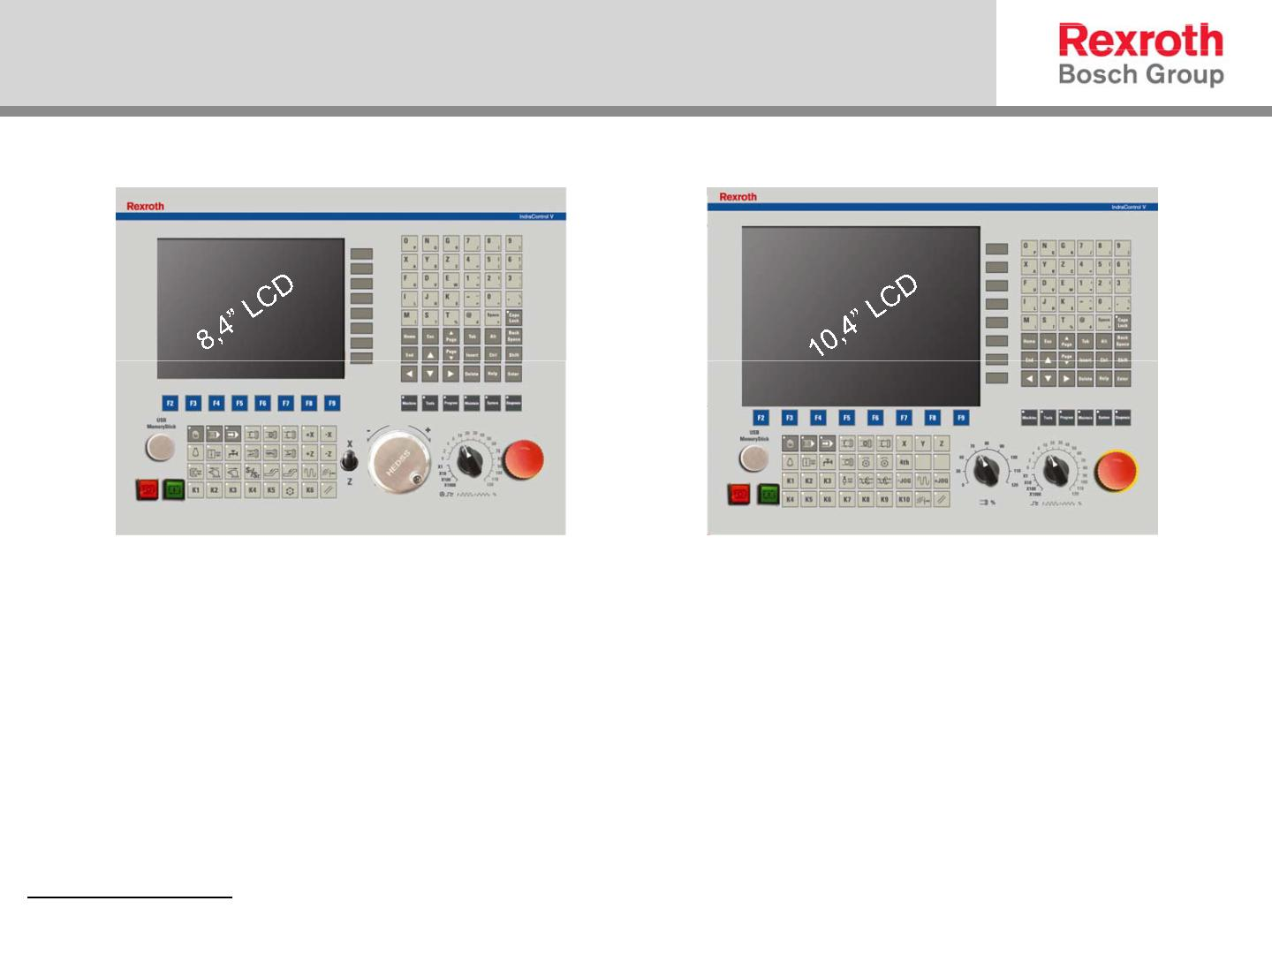

M功能键和标准键盘
M功能键
标准键盘
M功能键：和MTX系列功能键相同，与屏幕右侧显示的按钮一一对应。
标准键盘：与普通标准键盘标识相同，用shift键和alt键实现字符转换
功能。
Electric Drives and Controls 11/Mar/2009; BRCN/SLC31; Tiger Hu Hu
3
© All rights reserved by Bosch Rexroth AG, as well in cases of trade mark rights applications. All rights of disposal as copy of passing by us.
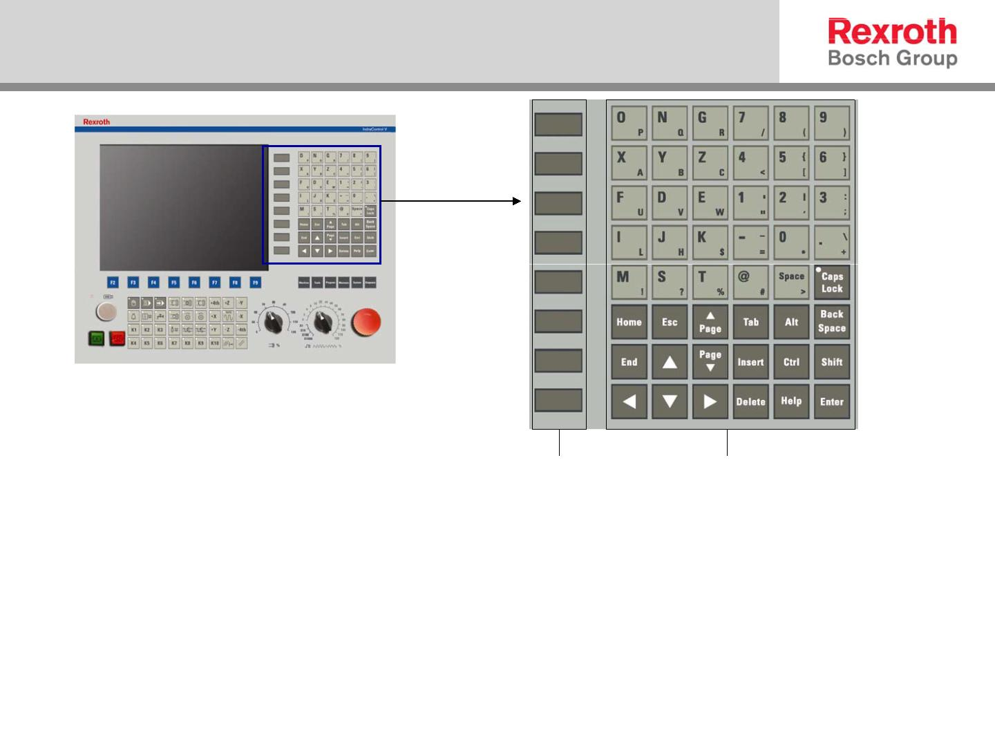

OP键，F功能键和机床操作区
 OP键：风格与MTX相似，用以完成6个操作区域
的切换。
Electric Drives and Controls 11/Mar/2009; BRCN/SLC31; Tiger Hu Hu
4
© All rights reserved by Bosch Rexroth AG, as well in cases of trade mark rights applications. All rights of disposal as copy of passing by us.
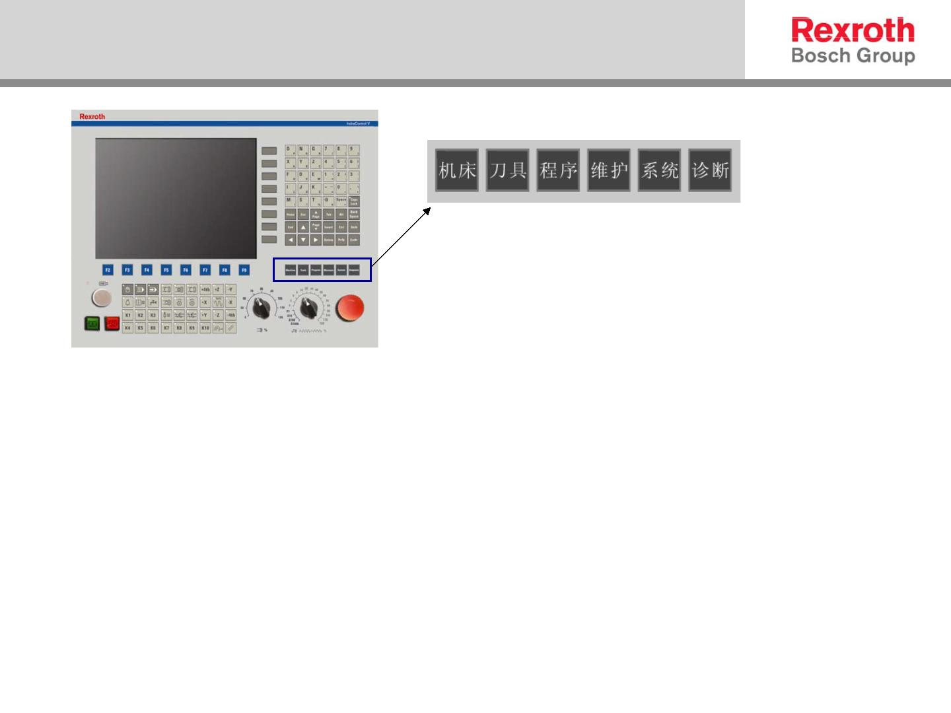

OP键，F功能键和机床操作区
 F功能键：与屏幕下侧显示的按钮一一对应
Electric Drives and Controls 11/Mar/2009; BRCN/SLC31; Tiger Hu Hu
5
© All rights reserved by Bosch Rexroth AG, as well in cases of trade mark rights applications. All rights of disposal as copy of passing by us.
