IndraMotion MTX micro - References
IndraMotion MTX micro –应用案例
2015.01
Electric Drives and Controls | | Mike Ying | 25/06/2013 | DCCN/SPF | © Bosch Rexroth AG 2013. All rights reserved,
also regarding any disposal, exploitation, reproduction, editing, distribution, as well as in the event of
applications for industrial property rights.
1
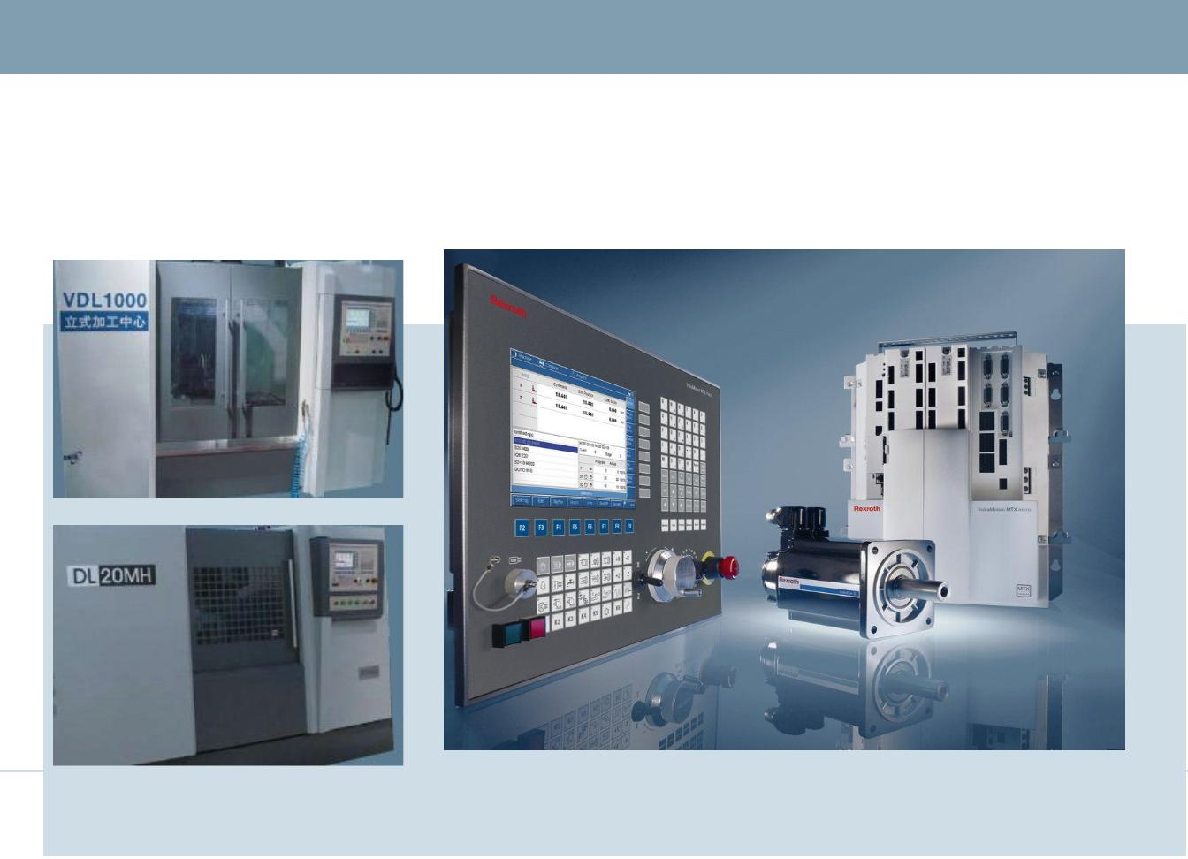

IndraMotion MTX micro - References
Rexroth MTX micro系统荣
获:
金属加工业2009年度
荣格技术创新奖
Electric Drives and Controls | | Mike Ying | 25/06/2013 | DCCN/SPF | © Bosch Rexroth AG 2013. All rights reserved,
also regarding any disposal, exploitation, reproduction, editing, distribution, as well as in the event of
applications for industrial property rights.
2
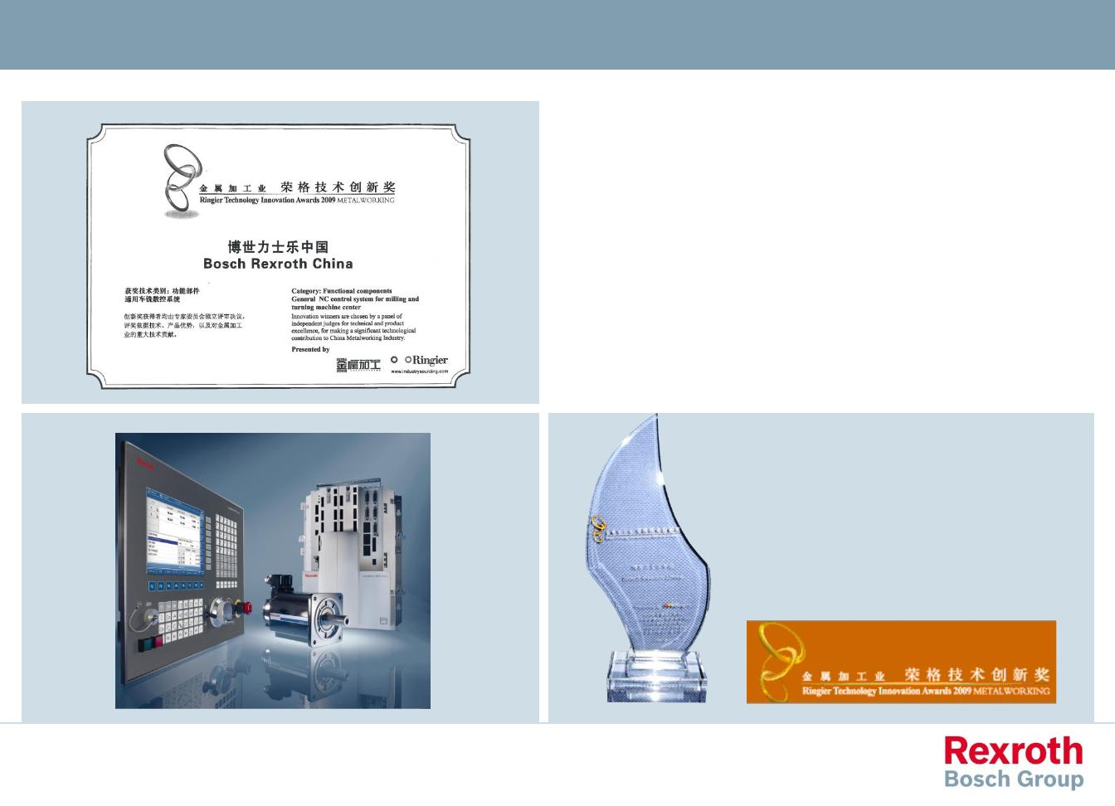

IndraMotion MTX micro - References
Rexroth MTX micro系统荣获:
金中国自动化网2009年度
创新产品奖
Electric Drives and Controls | | Mike Ying | 25/06/2013 | DCCN/SPF | © Bosch Rexroth AG 2013. All rights reserved,
also regarding any disposal, exploitation, reproduction, editing, distribution, as well as in the event of
applications for industrial property rights.
3
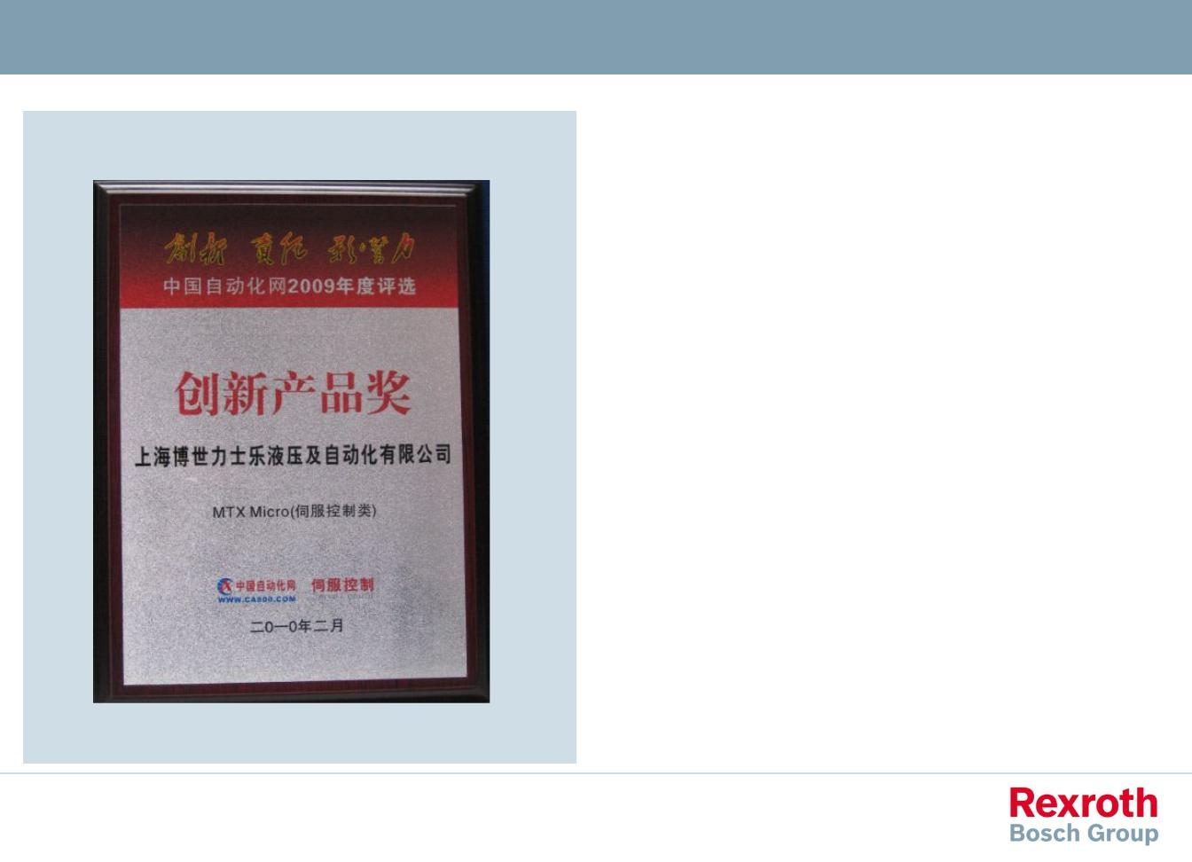

IndraMotion MTX micro - References
IndraMotion MTX micro:
CIMES 2010
TOP20创新奖
Electric Drives and Controls | | Mike Ying | 25/06/2013 | DCCN/SLC31 | © Bosch Rexroth AG 2013. All rights reserved,
also regarding any disposal, exploitation, reproduction, editing, distribution, as well as in the event of
applications for industrial property rights.
4
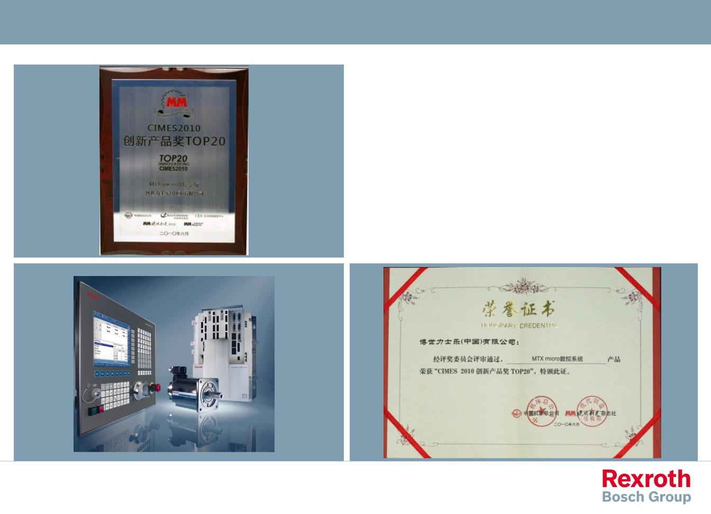

IndraMotion MTX micro - References
Electric Drives and Controls | | Mike Ying | 25/06/2013 | DCCN/SLC31 | © Bosch Rexroth AG 2013. All rights reserved,
also regarding any disposal, exploitation, reproduction, editing, distribution, as well as in the event of
applications for industrial property rights.
5
